

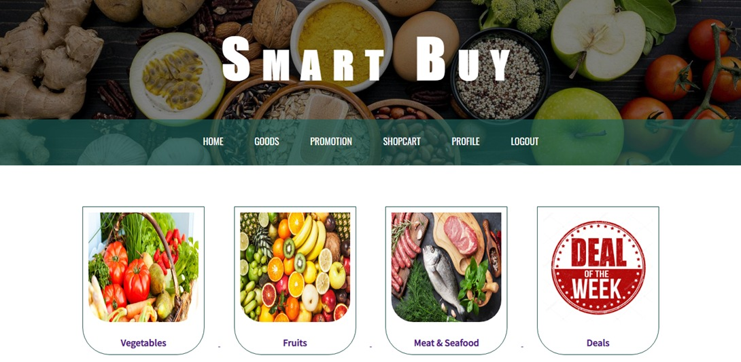

**IVE (Chai Wan)**

**Higher Diploma in Software Engineering**

|  |  |
| --- | --- |
| Supervisor:  Student: | Mr. Lo Wing Wah Terence  Fung Ka Wai  Wong King Hong  Cen WeiCheng  Cheng Chun Hei |

Market Smart Buy

# A. Introduction

We are now under the epidemic of COVID-19, so we will eat outside as little as possible. Instead, more people will go out to buy food and cook at home. In the market, the general public is more inclined to use contactless payment methods for consumption, and merchants also operate by using online payment methods to enhance market competitiveness and attract customers. Therefore, we want to provide the market with some suitable solutions (such as online payment and delivery functions) to develop in the new business environment after the epidemic.

The most residents may have the experience of spending a lot of time buying food and not being able to buy the food they want to buy. In our opinion, we need to use the Internet to create a platform that allows residents to receive recommendations of products and stores. So that they can buy the most expected product at a relatively low price and benefit from online payment and delivery. It will save much time and money, which fits our idea of creating a smart market platform.

## Objectives

|  |
| --- |
| **Market Smart Buy would enable the following:** |
| 1. Solve the problem of price transparency |
| 1. Help some store increase its visibility |
| 1. Avoid the hygiene problems caused by cash transactions |
| 1. Make some new residents familiar with the local market and purchase ingredients |
| 1. Help people save time or money to buy goods in the market or local stall. |
| 1. Help Shopkeeper develop new ways of selling |
| 1. Help manage the market and analyze market price flow |

1. **Aim of the project / Expected Outcomes**

The aim of this project is to solve the following problems:

1. People often cannot avoid going to market and touching with cash, which is unsanitary and increases the risk of infection.

2. For some people who are not often buying food, it is hard to find the ingredient they want to buy. In addition, they may not know the opening hours of the store and will find that the store is already closed when they go to the store. People won’t have this problem in online market.

3. People living in Hong Kong are very busy that they might not have time to buy goods in the market or local stall. They often get off work after the market close, so this platform can help them to buy goods at any time.

1. **Major Functions and Features**

## Functional

1. **Normal User**

* Write post on community to share food purchasing tips, experience and recipe.
* Leave a comment in other user’s post.
* Edit their account information. Including password, user nick name, and update new phone number.

1. **Shopkeeper (Seller)**

* Post a sales event with details like event title, event date and content of the event.
* Edit the details of the store. Including opening hours and location etc.
* Publishing promotion information such as Special discount at night
* Accept orders and edit orders‘ details (Price, quantity of items and status）

1. **Admin**

* Delete or disable specified type of account.
* Delete or modify any type of post including price share record and community post.
* Upgrade a normal account to a shopkeeper account.

## Non – Functional

**1. User Interface**

* The content planning should have high readability, resolution and conciseness to provide a better user experience.
* Font size and style can be change cater to needs.

**2. Fault tolerance**

* The system will remind and prevent the user when input error happens. For example, user input invalid symbol in password.

1. **Security**

* Sales record, user information will be encrypted to make sure no employee or hacker can steal the personal information.
* The server should content a firewall to block every packet with virus in it.

1. **Backup**

* Incremental backup will back up the sales record, showcase record and item quantity every day to make sure system can work normally after server failure.
* Full back up once a year, every full backup will save for three years.

# System Workflow

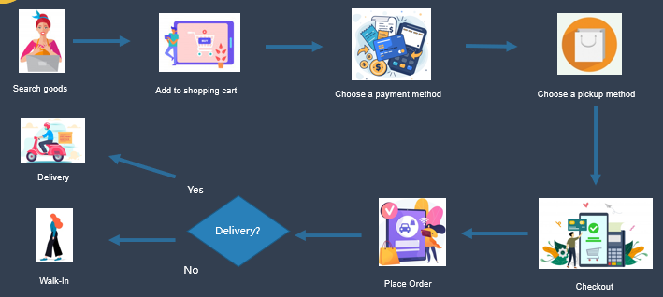

# User Interface

* + - 1. Website Home Page

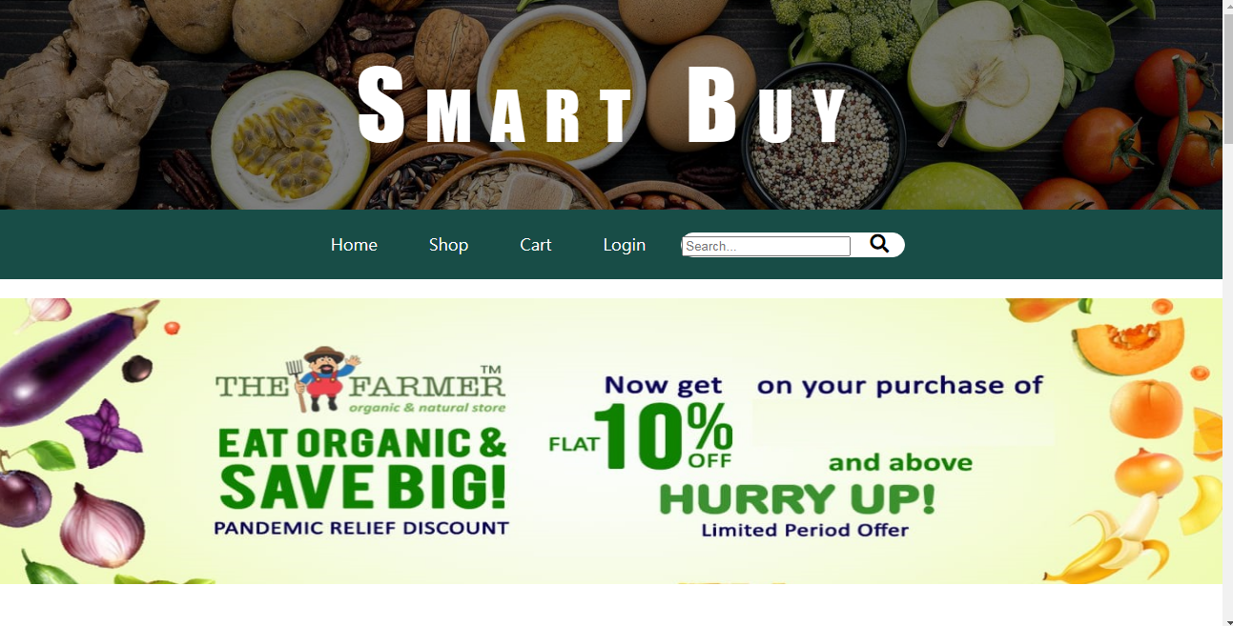

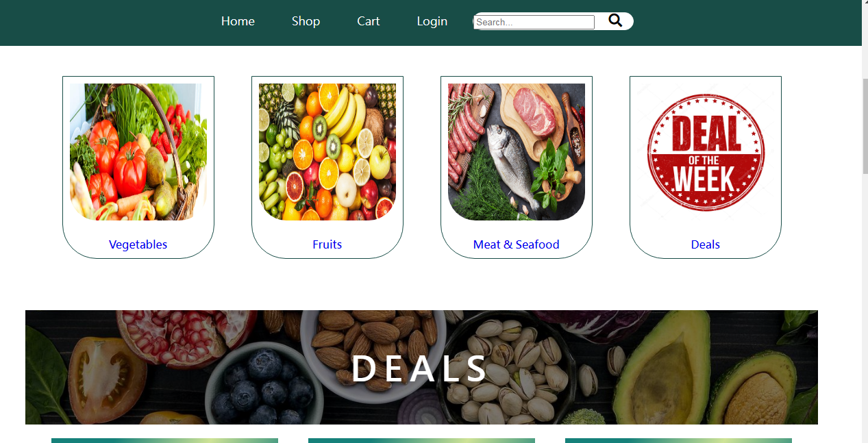

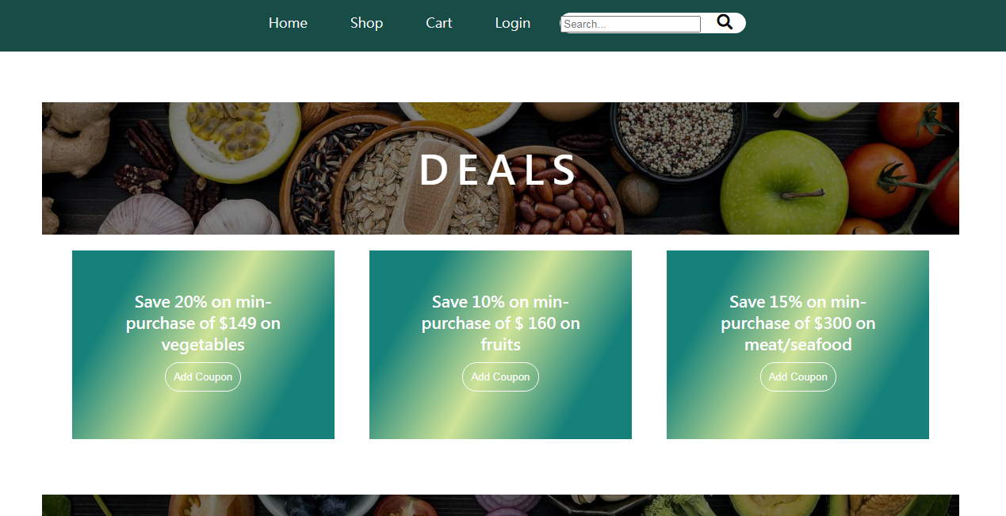

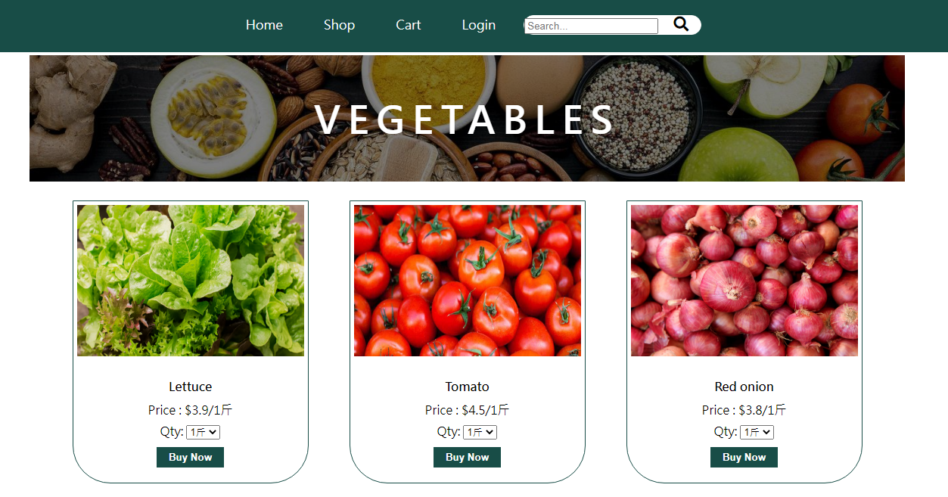

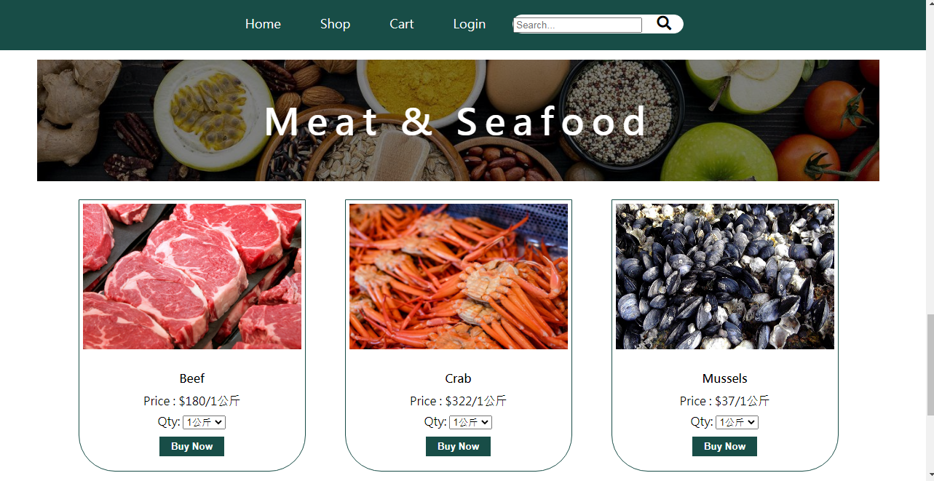

* + - 1. Shop List

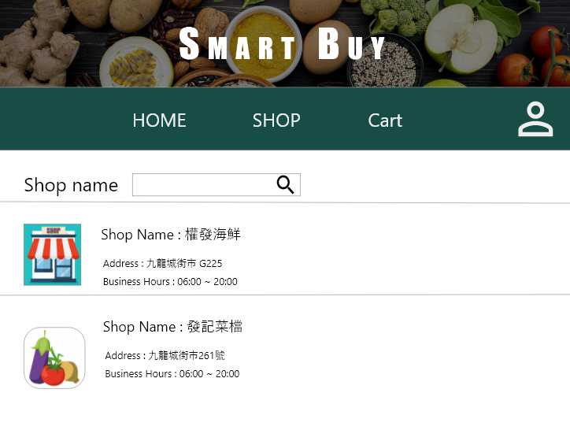

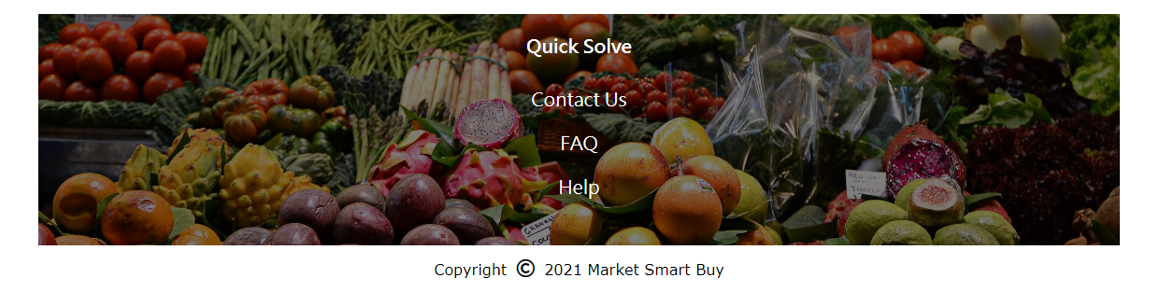

* + - 1. Stall List

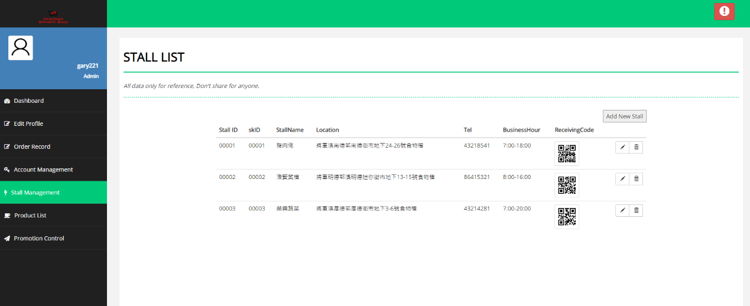

This page needs to admin permission to access, there are including all stall information such as stall name, location, tel. and payment code as well as admin can add new stall in this page.

### Upload Product

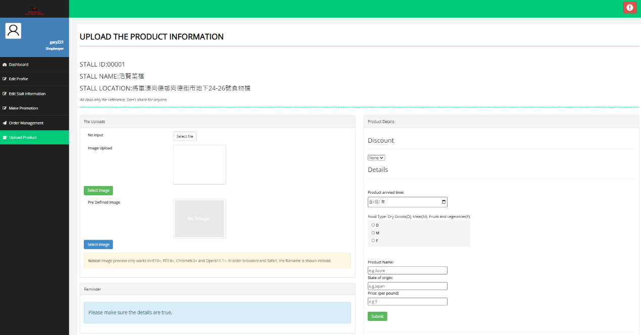

As a shopkeeper, this function is using to upload product of your stall. which can upload the image and typing the detail of the product such as setting discount, product arrived time, food type, product name, state of origin and price when you finish this form it will be uploaded into your stall page for the visitor to buy. But you should pre-login the shopkeeper account. If you don't have shopkeeper account is can't access into this page.

* + - 1. Mobile App Home Page

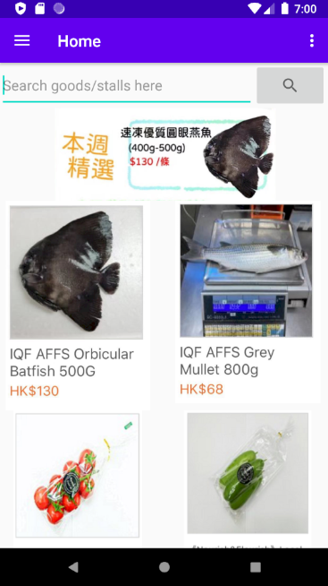

In Home page, user can search the goods or stalls by some keyword. There will be some promotion events showing to users at first. Besides, app will recommend some product with special offer and user can click on the product to view their details.

### 6.Local fresh

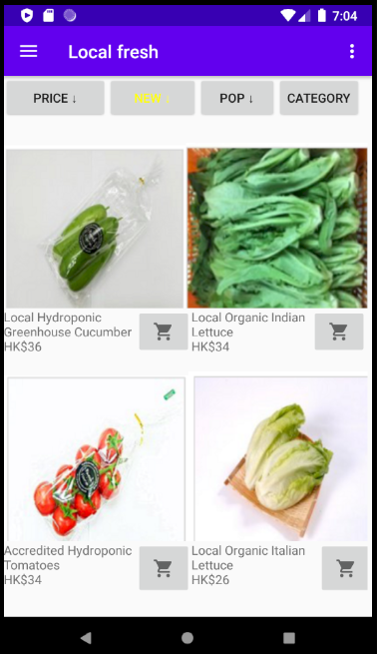

When users want to view some Local fresh, they can click the Local Fresh option on the navigation bar and the Local fresh page will display. It will display many products for user to select. User can click the button on the top, the product will be list by a certain order and the button will turn yellow to tell user the list has been sorted. User can click the shopping cart button to add the relate product to user’s shopping cart.

### 7.Make orders

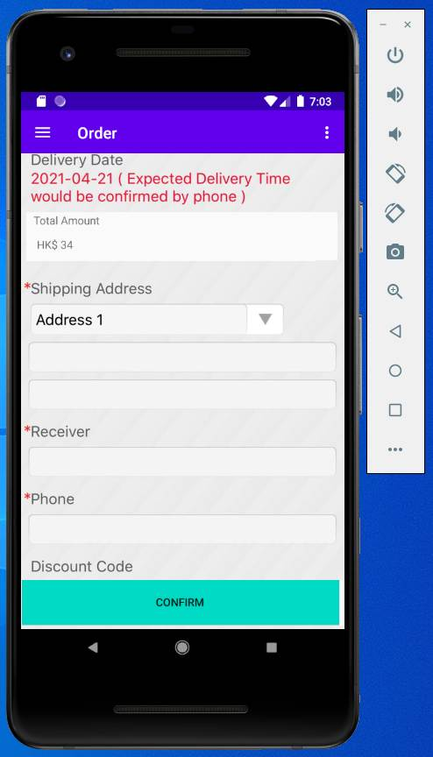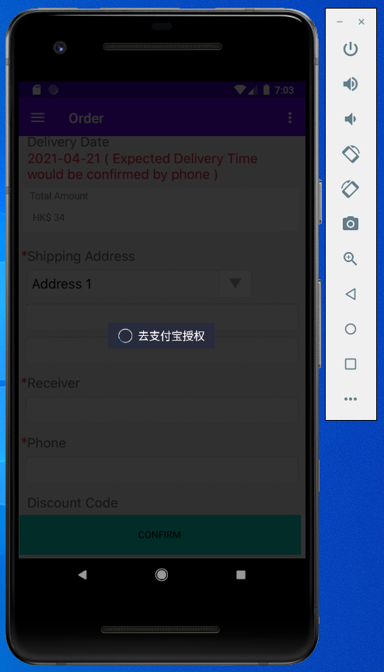

When the user decides to buy the items in the shopping cart, user should input more detail information Address, receiver and phone number to make an order.

The app will automatically jump to the Alipay payment page to complete the transaction.

### 8. Offline QR Code Scan

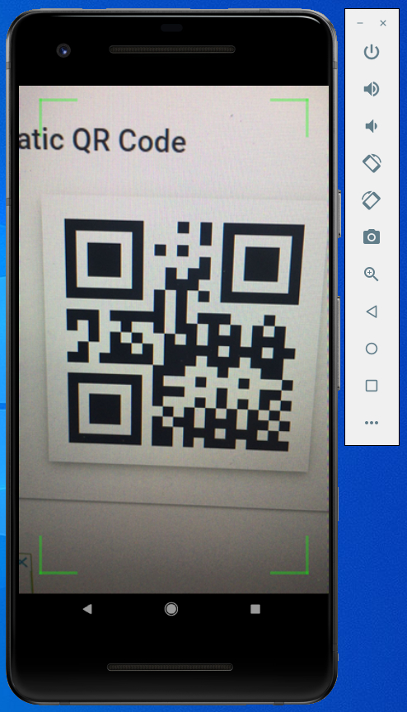

When users need to use app to purchase product offline, they should click the offline QU Code Scan option on the navigation bar and scan the QR code. It will redirect to external payment gateway to help user complete pay by phone.